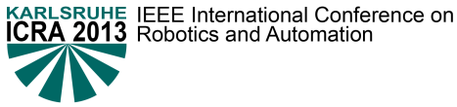

DFG Student Travel Support Request Form

The Form must be submitted to travel-support@icra2013.org before April 29, 2013, 24:00 (German Time)

Please do not modify the format of this form.

Please do not attach any supporting documentation to this form
Travel award eligibility: The applicant must be a student at a German university or research institution. This includes both PhD students and master students working on topics related to robotics and automation.

I. Student contact information:
Name: | Phone:
Email: | Country: Germany
Affiliation:

Topic of Phd/Master thesis (title, keywords):

II. Justification for Travel Request: (please do not exceed the space provided below)
How will travel support assist your research experience and education? Describe your involvement (e.g., paper presentation, participation in workshops) in the conference and/or the expected impact of participation in ICRA 2013 on your professional development.

III. Estimated Total Cost in EURO
Transportation from/to Karlsruhe |  | Conference registration
Lodging |  | Miscellaneous
Estimated TOTAL
Provide any justification for costs:

IV. Other Sources for Travel Funds
If applicable, the funding agency and grant title under which the research was performed. Note that this travel grant will not cover all expenses, so other funding sources should be available.
Source 1: | Funds:
Source 2: | Funds:

V. Phd Supervisor:
Name: | Email:
Affiliation:

